,,,,

1 – Computer Fundamental:

* ‘Computer’ or ‘Compute’ is a Greek word.
* Input ---> Process ---> Output
* COMPUTER: Common Operating Machine Purposely Used for Technological and Educational Research

**History:**

1. Human-computer. Where most people were women.
2. Then Abacus 🡪 Napler Bones 🡪 Pascalline 🡪 Leibniz Wheel 🡪 Jacquard Loom 🡪 Analytical Engine.
3. The Analytical Engine was a revolutionary thing. Charles Babbage invented the analytical engine, the father of the computer.
4. Then Census Machine 🡪 Mark 1

* The Abacus was invented in China.

**Generation of Computer:**

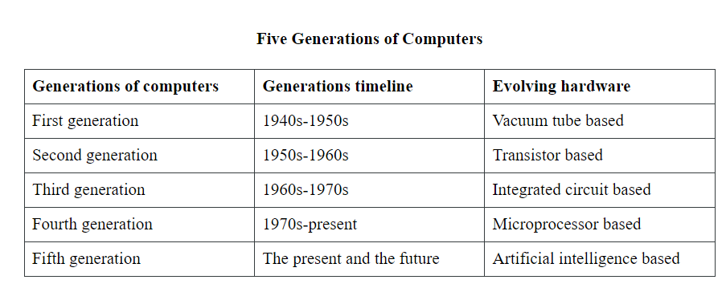

**Different types:**

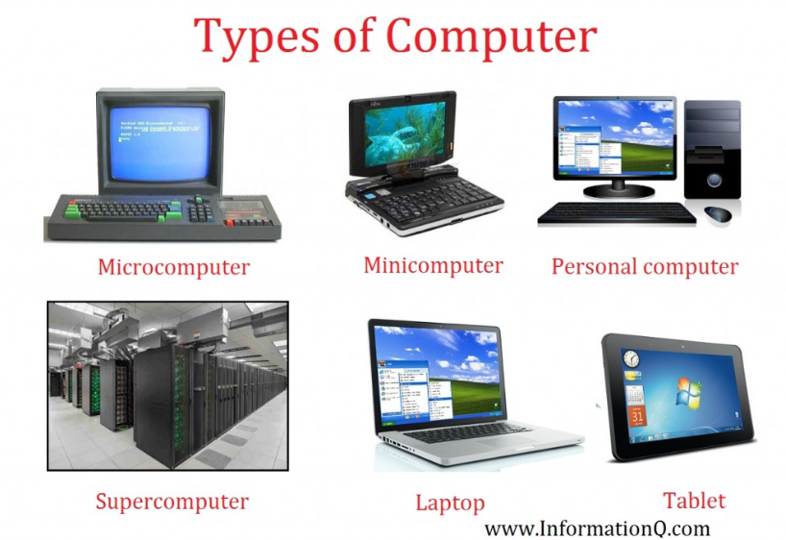



**Types based on Mechanism:**

* Data type:
  + - Digital --- Input(bit data) 🡪 output on the screen. Like, a calculator, Mobile phone, PC, etc.
    - Analog --- Input(Singal) 🡪 Then generate a result. Like, a voltmeter, a thermometer, etc.
    - Hybrid --- Digital + Hybrid.

**Components of Computer:**

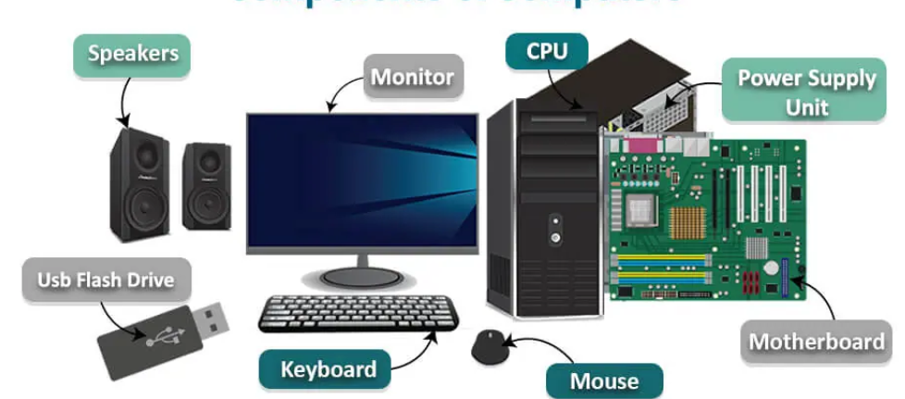

**Functional Diagram of Components:**

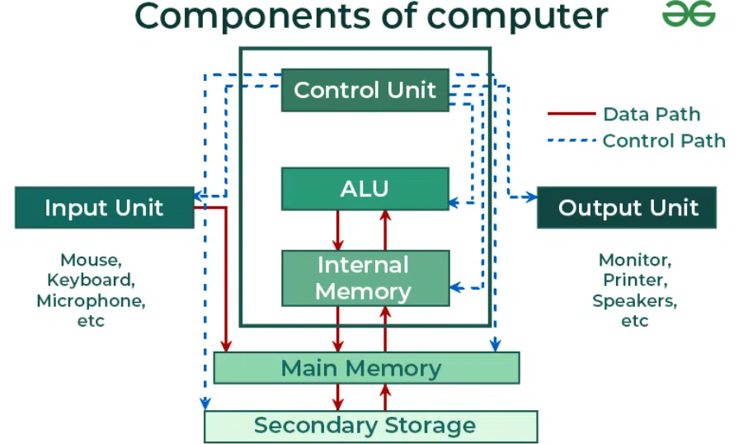



**5 Components of Computer:**

